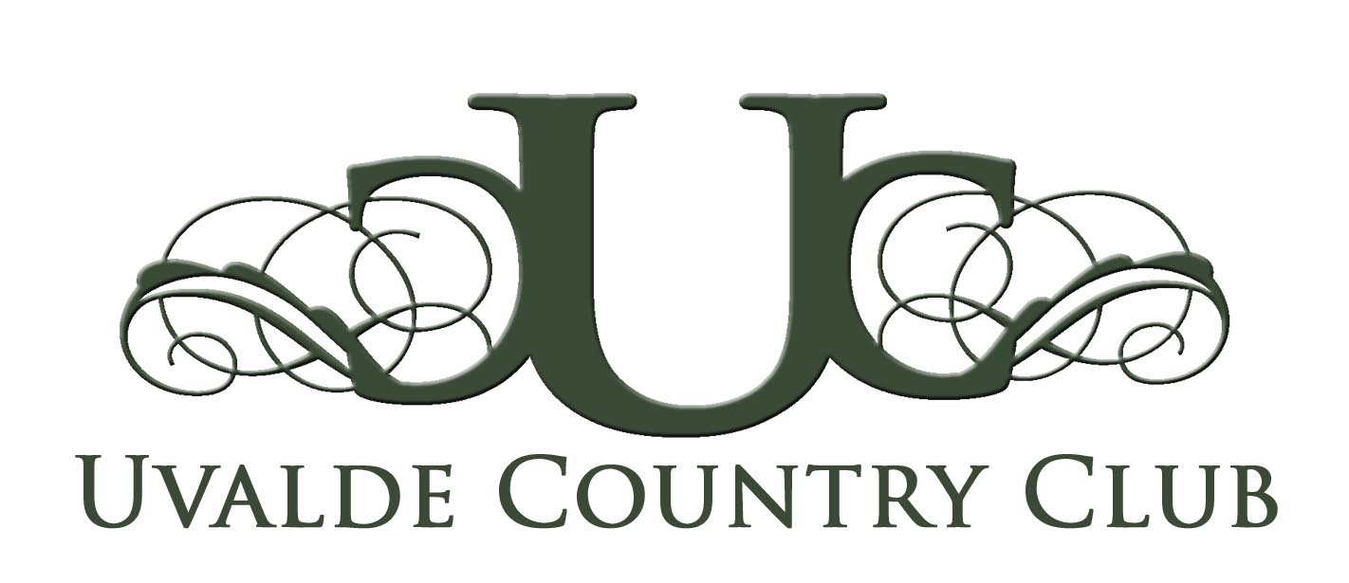

BAR Association Luncheon in Ballroom
Thursday, April 10, 2014
Arrival: 11:30 am Lunch: 11:45

Chicken Scaloppini
Over Angel Hair Pasta and Vegetable Medley with fresh herbs and Shallots
$23.00

Wedge Salad w/ Cheddar Cheese & Ranch Dressing

NY Style Cheesecake Topped w/ Fresh Strawberry Glaze
All meals include ice water and tea & are subject to Sales Tax and 20% Gratuity

